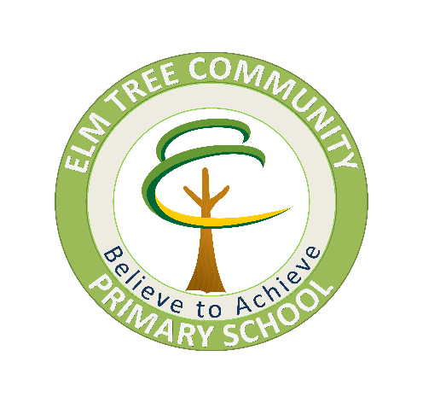

Mathematics Policy

2023/24

“Mathematics is a creative and highly interconnected discipline that has been developed over centuries, providing the solution to some of history’s most intriguing problems. It is essential to everyday life, critical to science, technology and engineering, and necessary for financial literacy and most forms of employment. A high-quality mathematics education therefore provides a foundation for understanding the world, the ability to reason mathematically, an appreciation of the beauty and power of mathematics, and a sense of enjoyment and curiosity about the subject.” (DfE – National Curriculum, 2014)

The aims of the 2014 National Curriculum are for our pupils to:
- become fluent in the fundamentals of mathematics, including through varied and frequent practice with increasingly complex problems over time, so that pupils develop conceptual understanding and the ability to recall and apply knowledge rapidly and accurately
- reason mathematically by following a line of enquiry, conjecturing relationships and generalisations, and developing an argument, justification or proof using mathematical language
- can solve problems by applying their mathematics to a variety of routine and non-routine problems with increasing sophistication, including breaking down problems into a series of simpler steps and persevering in seeking solutions.

This policy should be read in conjunction with the following school policies for each pathway:
- Assessment Policy
- Marking Policy

Developing Cultural Capital within Maths
“It is the essential knowledge that pupils need to be educated citizens, introducing them to the best that has been thought and said, and helping to engender an appreciation of human creativity and achievement.”

Essential knowledge that pupils need to be educated citizens
Skills within and beyond the national curriculum are developed by covering topics within the curriculum for example place value, calculations, shape space and measure etc then applying these skills into more of an everyday context. At Elm Tree children are supported to recognise that Maths is everywhere and we are committed to providing our children with as many opportunities to apply their mathematical knowledge into everyday situations for example reading a train timetable or going to the shop with a budget.

Introducing to the best that has been thought and said
At Elm Tree we are committed to developing an awareness of famous mathematicians and inventions for example the calculator but also on developing a knowledge of the impact of Mathematics into other professions for example how Maths impacts on the production of video games or music production.

Helping to engender an appreciation of human creativity and achievement
Through the delivery of our Maths curriculum we deliver an appreciation of Maths and recognition of the impact of Maths upon wider society. Children develop an awareness that Maths is everywhere an by appreciating what we see we are able to reflect on how Maths has contributed to this for example, sports analysis, town planning, building etc. Children also develop an appreciation of others for example using Maths to develop an understanding of democracy for example voting for a book, or the schools adopted animal etc.

Intent
Why do we teach this? Why do we teach it in the way we do?
Elm Tree Community Primary School provides a broad and varied Mathematics curriculum, through a variety of teaching approaches and learning situations, to meet the needs of all our pupils. At Elm Tree, we are committed to developing the pupils’ all-round approach to Maths using varied methods and cross-curricular input.
In teaching children mathematics, we aim for our children to have:
- A positive attitude towards mathematics
- Competence and confidence in mathematical knowledge, concepts and skills
- An ability to solve problems, reason, think logically and to work systematically and accurately
- An initiative and an ability to work both independently and in cooperation with others
- An ability to communicate clearly using mathematical terminology
- An ability to use and apply mathematics across the curriculum and in real life
- An understanding of mathematics through a process of enquiry and experiment
- to promote enjoyment of learning through practical activity, ICT, exploration and discussion

Implementation
What do we teach? What does it look like?
At Elm Tree we use the TT Education 'Path 2 Success' to progress our children from shallow learning, to deep learning and ultimately profound learning.
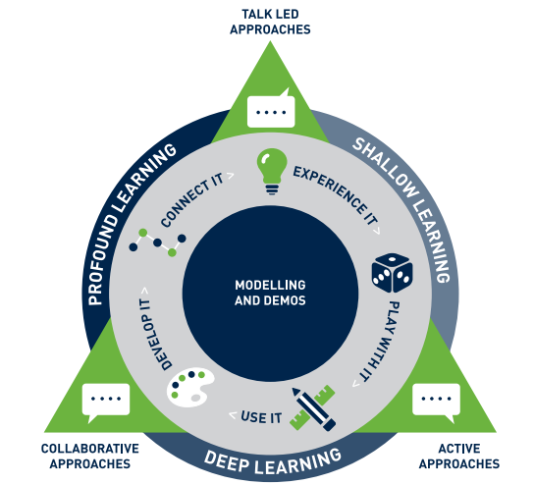

Stage 1- Experience It
Children need rich experiences which they can relate in order to support them in developing their mathematical skill set. Children in this stage will be accessing continuous provision and being introduced to a range of rich vocabulary. During this stage our focus is on creating and replicating meaningful experiences and practical applications.
Stage 2- Play with It
This stage refers to the gamification of learning which can be seen in our Maths carousels. During this stage we use the power of games to practice key skills on a daily basis. Through mathematical games we are able to engage our children and provide challenge to develop both procedural and conceptual understanding.
Stage 3- Use It
This stage refers to the practical application of the skill and within our carousel approach this stage refers to the direct teaching of Maths and new input. When teaching Maths we use the CPA approach.
Stage 4- Develop It
Children need the opportunity to continue to develop the skill in context. This stage is underpinned by an active, talk-led, collaborative learning climate as this way children will be more likely to remember it. Children are given opportunities to talk about their knowledge of Maths through for example, A & B games or partner games.
Stage 5- Connect It
During this stage children are making connections across the curriculum. Children now have a deeper understanding of mathematical concepts and are beginning to make links in connections both within mathematical lessons, across the curriculum and ultimately into the wider world.

CPA Approach
At Elm Tree Community Primary School, Maths is taught through a mastery approach through concrete-pictorial-abstract (CPA). Through the use of these key stages in their learning, each child forms the understanding of maths concepts and skills at their specific level, which they are learning and can apply them to a range of contexts. We believe that children must be supported in developing their understanding of Problem Solving, Reasoning and Numeracy in a broad range of contexts in which they can explore, enjoy, learn, practise, and talk about their developing understanding.
Elm Tree are adopting a mastery approach throughout school using CPA through the White Rose Schemes.
Abstract
Pictorial
Concrete

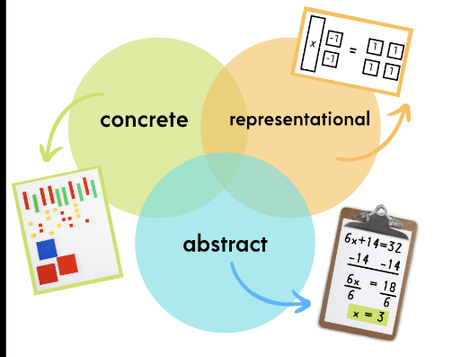
We recognise that CPA is not a linear approach and rather a cyclical approach.

Concrete:
- Each skill or concept is first modelled with concrete materials (e.g. counters, cubes, base ten, bead strings.).
- Children are provided opportunities to practice and demonstrate mastery using concrete materials.
Pictorial:
- The maths concept or skill is next modelled at the representational (semi-concrete) level which involves drawing pictures that represent the concrete objects previously used (e.g. tallies, dots, circles)
- Children are provided opportunities to practice and demonstrate mastery by drawing solutions.
Abstract:
- The math concept/skill is finally modelled at the abstract level (using only numbers and mathematical symbols).
- Children are provided opportunities to practice and demonstrate mastery at the abstract level before moving to a new maths concept/skill.
- As a teacher moves through a concrete-pictorial-abstract sequence, the numbers and/or symbols should be used in conjunction with the concrete materials and representational drawings (promotes association of abstract symbols with concrete & representational understanding).

Concrete manipulatives are used to help children work through new concepts and challenging questions and provide a transition to pictorial and abstract. Maths lessons aren't about teaching tricks; they are about giving children the tools to understand the problem in front of them. In a mastery classroom, there doesn’t have to be a linear progression from concrete to pictorial to abstract. Instead, teachers apply a cyclical approach. For example, even when a pupil has worked out the answer using an abstract method, it is worth asking them to use concrete manipulatives to convince others that they are correct.
Providing the same bank of resources to all teaching staff will allow children to become familiar with different types of equipment across the school- thus providing consistency for our children.

Impact
What will this look like? By the time children leave our school they will:
By the end of KS2 we aim for children to be fluent and develop mastery in the fundamentals of mathematics with a conceptual understanding and the ability to recall and apply knowledge accurately. They should have basic skills to solve problems by applying their mathematics to a variety of situations, including in unfamiliar contexts and application to real-life scenarios.

Pre-Formal Teaching
At Elm Tree we have high expectations of all our children and strive for all of our children to be accessing formal Maths teaching following our Maths overview and our Calculation Policy. It is however important to note that any Maths document should be read in conjunction with the “Elm Tree Early Maths Overview”. For some of our younger cohorts at Elm Tree their developmental and cognitive delay poses challenges in their ability to access and engage with formal Maths lessons. In light of this, it is crucial for us to support the individual needs of every child and provide appropriate and tailored mathematical learning opportunities.
Children working below Range 5 will be taught Maths through continuous provision and pre-formal learning strategies. This approach allows for a more hands-on, experiential, and concrete learning experience, which can better align with their current developmental abilities. During continuous provision, these children are provided with a range of carefully planned and structured activities that encourage the acquisition of mathematical skills and concepts. These activities are embedded within their daily routines and learning experiences and take into account their unique learning styles and needs building a strong foundation for future formal learning.
Whilst these children are not currently engaging in formal Maths lessons, it is essential to note that they are still progressing and deepening their mathematical understanding through accessing continuous provision and pre-formal learning approaches. We are documenting their progress and regularly assessing their development so that we have a comprehensive overview of their learning journey. When children reach Range 5 they will be introduced to short teacher inputs and they will start a transition into formal Maths lessons at which point the Calculation Policy will be followed in conjunction with the Maths overview. It is important to note that for many children they will continue to develop their Mathematical understanding through formal teaching and through continuous provision throughout their time at Elm Tree.
Problem Solving at Elm Tree

Aims and Objectives

- To develop and nurture children's problem-solving skills in mathematics, enabling them to become confident, independent, and resilient problem solvers.
- To enable children to understand the relevance and application of mathematical concepts in everyday life situations.
- To support children in developing their logical reasoning, critical thinking, and decision-making abilities.
- To foster a positive attitude towards mathematics and promote enjoyment and engagement in problem-solving activities.

Strategies for Teaching and Learning

Due to the complex and varied needs of the children attending Elm Tree Community Primary School problem solving is taught in different ways across each class. Teachers have a thorough understanding of the speech, language and communication needs of all of our children and take into account speech and language reports and their blank level assessments at all times. Strategies to teach problem solving may include but are not limited to the strategies below.

Embedding Problem-Solving in the Mathematics Curriculum

We recognise problem-solving is an integral part of mathematics and through lessons and opportunities across the school day we ensure our children have opportunities to explore, apply, and consolidate their mathematical understanding. Teachers will incorporate into their lessons or continuous provision a variety of problem-solving tasks, including open-ended questions, real-life scenarios, and puzzles, to stimulate critical thinking and encourage creative approaches to problem solving.

Promoting Mathematical Talk

Throughout the day all our staff will encourage children to articulate their mathematical thinking and reasoning skills through discussions, group work, and sharing ideas. They will use prompting questions to guide children's thinking and promote deeper understanding. Mathematical talk will be valued, and mistakes will be seen as opportunities for learning. It is important to recognise that Mathematical talk at Elm Tree is not limited to “talk” some of our children are not able to verbalise their mathematical understanding due to their individual SLCN needs and therefore we provide opportunities for our children to instead show their mathematical understanding.

Providing Scaffolded Support

Adults supporting problem solving will gradually reduce support as children develop their skills. They will provide appropriate scaffolds, such as visual representations, manipulatives, and modeling, to help children understand and solve problems effectively.

Cross-curricular Links

Teachers will make connections between problem-solving activities and other areas of the curriculum, facilitating the application of mathematical concepts in real-life contexts. This approach will enable children to transfer their problem-solving skills across various subjects thus making learning meaningful and relevant.

